Computer vision 1

Homework 7

姓名 ： 蘇宛琳

系所 ： 電信所碩一

學號 ： R05942060

指導教授 ： 傅楸善老師

Computer Vision Report – Homework 7

R05942060 蘇宛琳

Question :

Write a program to generate thinned image. Down sample lena.bmp from 512*512 to 64*64 first. Sample pixels positions at each 8*8 top-left corner, so everyone will get the same answer .

  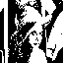

lena.bmp DownsampleLENA.bmp binarizelena.bmp

The thinning operator is the combination of

1. Mark-Interior/Border-Pixel : Get “*b”* and “*i”*
2. The Pair Relationship : Mark “*b”* pixels that are next to “*i”*
3. Connected Shrink : Shrink marked pixels that are deletable

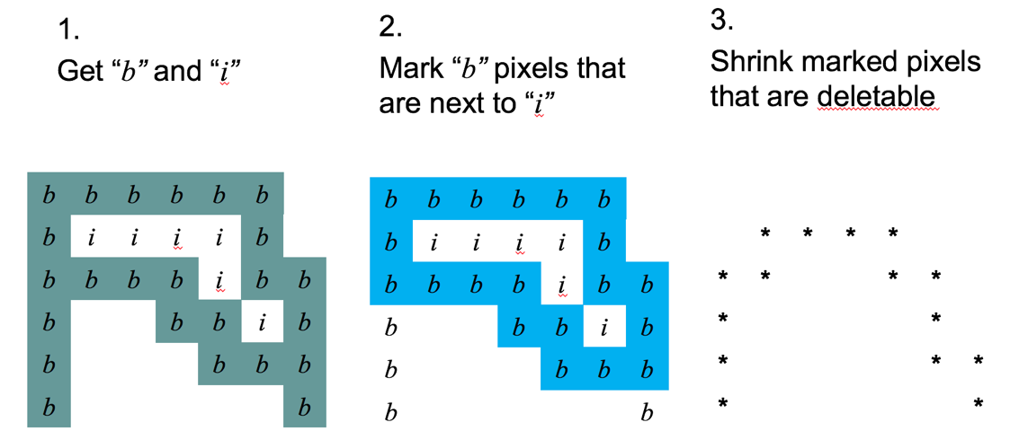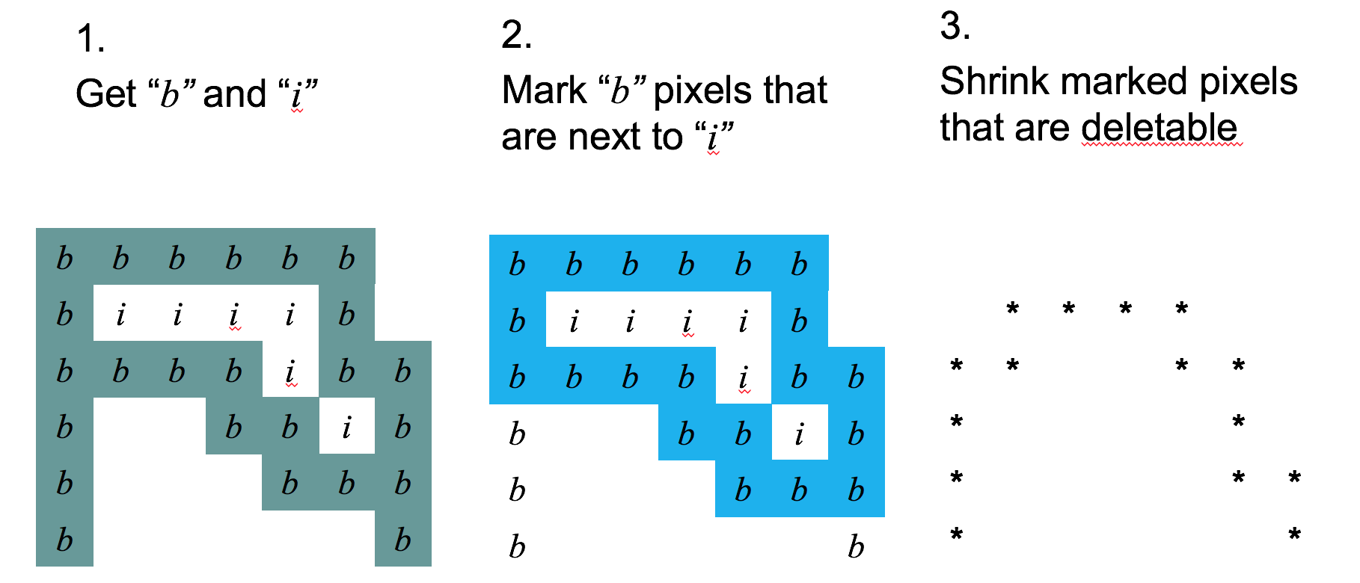

**\* Thinning function Concept \***

Step1. 先將灰階的 512*512 每 8 點取 1 點降取到 64*64，並以 128 為門檻值做二元化。 Step2. 利用Yokoi Connectivity Number function, The Pair Relationship function, Connected Shrink function，產生thinned image。

**Source code (Main code)**

clear;

close;

**Grayscale LENA image**

LENA = imread('lena.bmp');

INFO = imfinfo('lena.bmp');

**Down Sample from 512x512 to 64x64**

for x = 1 : INFO.Height/8,

for y = 1 : INFO.Width/8,

DLENA(x,y) = LENA(x*8-7,y*8-7);

end;

end;

**Sample pixels positions at each 8*8 top-left corner**

imwrite(DLENA,'DownsampleLENA.bmp')

**Binarize LENA image**

for x = 1 : INFO.Height/8,

for y = 1 : INFO.Width/8,

T = 128;

if DLENA(x,y) > T,

NEWLENA(x,y) = 255;

else

NEWLENA(x,y) = 0;

end;

end;

end;

imwrite(NEWLENA,'binarizelena.bmp')

**Thinning function**

A3 = NEWLENA;

change = 1;

while change ~= 0

A3_pre = A3;

% Yokoi Connectivity Number

A1 = YokoiConnectivity(A3);

% The Pair Relationship

A2 = PairRelationship(A1);

% Connected Shrink

A3 = ConnectedShrink(A3,A2);

change = sum(abs(A3_pre(:)-A3(:)));

end

figure;

subplot(1,3,1); imshow(DLENA); title('Downsampling');

subplot(1,3,2); imshow(NEWLENA); title('Binarize');

subplot(1,3,3); imshow(A3); title('Thinning');

saveas(gcf,'Thinning.jpg');

**Print Result Label & Write Result to txt file**

Iycn = YokoiConnectivity(NEWLENA);

Iycn(A3 == 1) = '*';

fid = fopen('Thinning.txt','w');

for k = 1 : size(Iycn,1)

fprintf(fid,'%c',Iycn(k,:));

fprintf(fid,'\r\n');

end

fclose(fid);

Mark-interior/Border-pixel

**\* Yokoi Connectivity function Concept\***

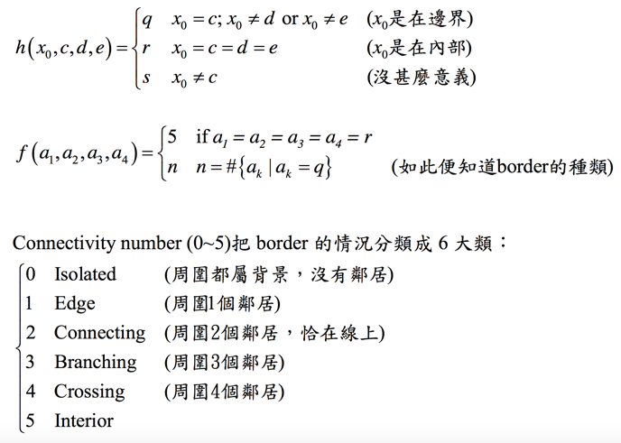

function output = YokoiConnectivity(NEWLENA)

Ib = zeros(size(NEWLENA,1)+2,size(NEWLENA,1)+2);

Ib(2:end-1,2:end-1) = NEWLENA;

[r,c] = find(Ib);

output = char(size(NEWLENA));

for i = 1 : length(r)

mask = Ib(r(i)-1:r(i)+1,c(i)-1:c(i)+1);

a = zeros(1,4);

a(1) = h(mask(5),mask(8),mask(7),mask(4)); % x0,x1,x6,x2

a(2) = h(mask(5),mask(4),mask(1),mask(2)); % x0,x2,x7,x3

a(3) = h(mask(5),mask(2),mask(3),mask(6)); % x0,x3,x8,x4

a(4) = h(mask(5),mask(6),mask(9),mask(8)); % x0,x4,x5,x1

output(r(i)-1,c(i)-1) = f(a);

end

end

**\* h function Concept\***

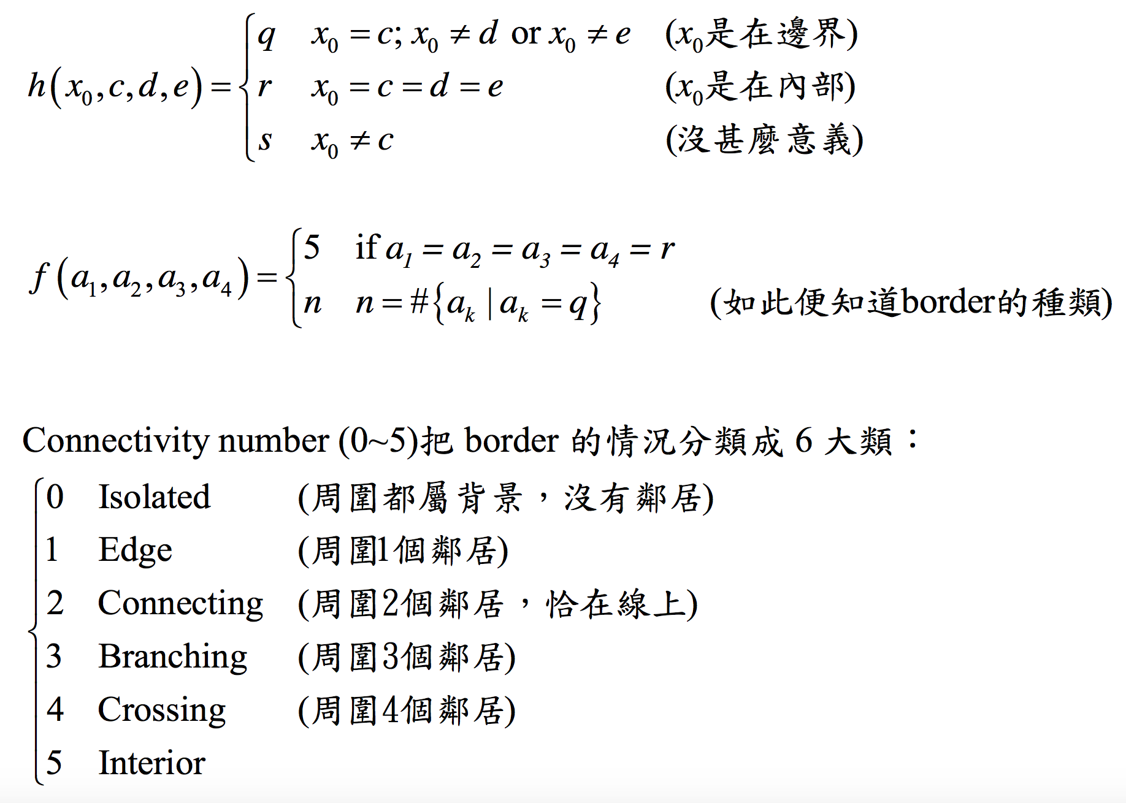

function output = h(b,c,d,e)

if b == c,

if d == b && e == b,

output = 'r';

else

output = 'q';

end

else

output = 's';

end

end

**\* f function Concept\***



function n = f(a)

if all(a == 'r')

n = num2str(5);

else

n=num2str(sum(a == 'q'));

end

end

input : original symbolic image

output : interior/border image

Pair relationship operator

**\* Pair Relationship function Concept\***

4-connected 中鄰居們有一個以上的鄰居為前景而且本身也為前景，那麼將自己視為 一個可以被刪除的點;若本身為孤立點沒有鄰居則不能被刪除。

function output = PairRelationship(A1)

Ib = zeros(size(A1,1)+2,size(A1,1)+2);

Ib(2:end-1,2:end-1) = A1;

[r,c] = find(Ib);

output = char(zeros(size(A1)));

for i = 1 : length(r)

mask = Ib(r(i)-1:r(i)+1,c(i)-1:c(i)+1);

a = zeros(1,4);

a(1) = h1(mask(8)); % h1(x1,1)

a(2) = h1(mask(4)); % h1(x2,1)

a(3) = h1(mask(2)); % h1(x3,1)

a(4) = h1(mask(6)); % h1(x4,1)

output(r(i)-1,c(i)-1) = f1(a,mask(5));

end

end

**\* h1 function Concept\***

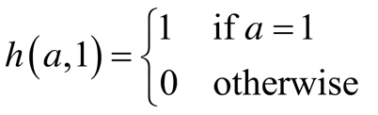

function output = h1(b)

if b == '1'

output = 1;

else

output = 0;

end

end

**\* f1 function Concept\***

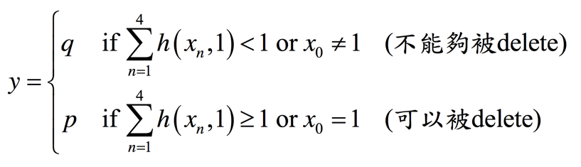

function y = f1(a,b)

if sum(a) >= 1 && b == '1'

y = 'p';

else

y = 'q'; % x0 have no neighbor

end

end

input: interior/border image

output: marked image

Connected Shrink

**\* Connected Shrink function Concept\***

前景區域縮小但不使連結斷開 (recursive)

function output = ConnectedShrink(NEWLENA,A2)

Ib = zeros(size(NEWLENA,1)+2,size(NEWLENA,1)+2);

Ib(2:end-1,2:end-1) = NEWLENA;

[r,c] = find(A2 == 'p');

r = r + 1;

c = c + 1;

for i = 1 : length(r)

mask = Ib(r(i)-1:r(i)+1,c(i)-1:c(i)+1);

a = zeros(1,4);

a(1) = h2(mask(5),mask(8),mask(7),mask(4)); % x0,x1,x6,x2

a(2) = h2(mask(5),mask(4),mask(1),mask(2)); % x0,x2,x7,x3

a(3) = h2(mask(5),mask(2),mask(3),mask(6)); % x0,x3,x8,x4

a(4) = h2(mask(5),mask(6),mask(9),mask(8)); % x0,x4,x5,x1

Ib(r(i),c(i)) = f2(a,mask(5));

end

output = Ib(2:end-1,2:end-1);

end

**\* h2 function Concept\***

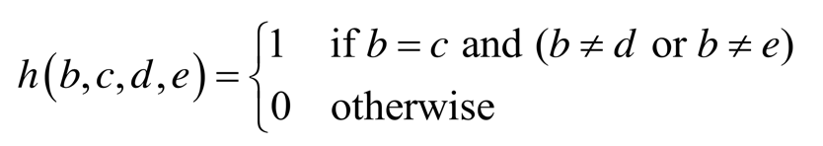

function output = h2(b,c,d,e)

if b == c && (d ~= b || e ~= b)

output = 1;

else

output = 0;

end

end

**\* f2 function Concept\***

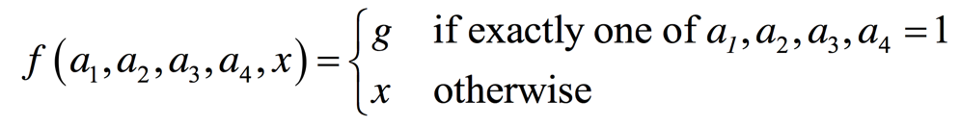

function y = f2(a,x)

if sum(a) == 1

y = 0;

else

y = x;

end

end

**\* 直接貼過來的結果數據 \***

**\*\*\* ******** \***

**\*\*\* **** * * \***

**\*\*\* *** * ******* \***

**\* * **** * * * \***

**\*\*\* * * * * * \***

**\*\* ** * ** * * \*\*\*\***

**\*\* * * ** * * ** \*\***

**\* * * ** ** ** \*\*\*\*\*\*\***

**\* * * * ***** ** \***

**\* * * ** * \***

**\*\* * * * * \***

**\* * * ** * *** \***

**\* * * * * \***

**\* ******** * * \***

**\* * *** ** * * \*\***

**\* * ** * * * * \***

**\* * *** * *** \***

**\* * ** **** * * \***

**\* * *** * *** * **** \*\***

**\* * * ******** * * ** * * * \***

**\* * ** * * * * * ******* * \***

**\* * * *** * * * **** \***

**\* *** * ** * * ** * \*\***

**\* * * *** * * * \***

**\* *** * *** * *** \***

**\* ** * * * *** \*\*\*\*\*\*\***

**\* * * * * \***

**\* * * ** * * \***

**\* * ***** ** \***

**\* * * **** * ** \***

**\* ** ***** * ** \*\*\*\***

**\* * * ** * * *** \*\***

**\* ** ** * * * \*\***

**\* ** * * * * \***

**\* ** * *** * * * * \***

**\* ** * * ** * * * * * \***

**\* * ** ** * * * * * \*\***

**\* * * * **** * * \*\***

**\* * * * ** ******** **** * ** \*\***

**\* * * * * * * \***

**\* * * ** * * * * \*\*\*\*\*\*\***

**\* * * * * * ** \***

**\* * * * ********** * * ** \***

**\* * ** * *** ** * \***

**\* * * ** * * * ** * \***

**\* * * * ** * * * \*\*\***

**\* * ** * ****** * \*\***

**\* * **** ** * \*\*\***

**\* * ** * \***

**\*\*\* ** * * * \***

**\* * * * * ** \*\*\***

**\*\* * * ** \***

**\*\* ** * * **** \***

**\* * * ** * \*\***

**\* *** * * * ** \*\*\*\***

**\* * *** ** * \*\*\***

**\* * * * *** \***

**\*\* ** * * \*\*\*\*\***

**\* * * ***** \***

**\* * *** ** \***

**\* * ** *** \*\***

**\* * *** ** \***

**\* ** * ** \*\*\***

**\* \*\*\***

**\* 整理過後得到的結果圖 \***

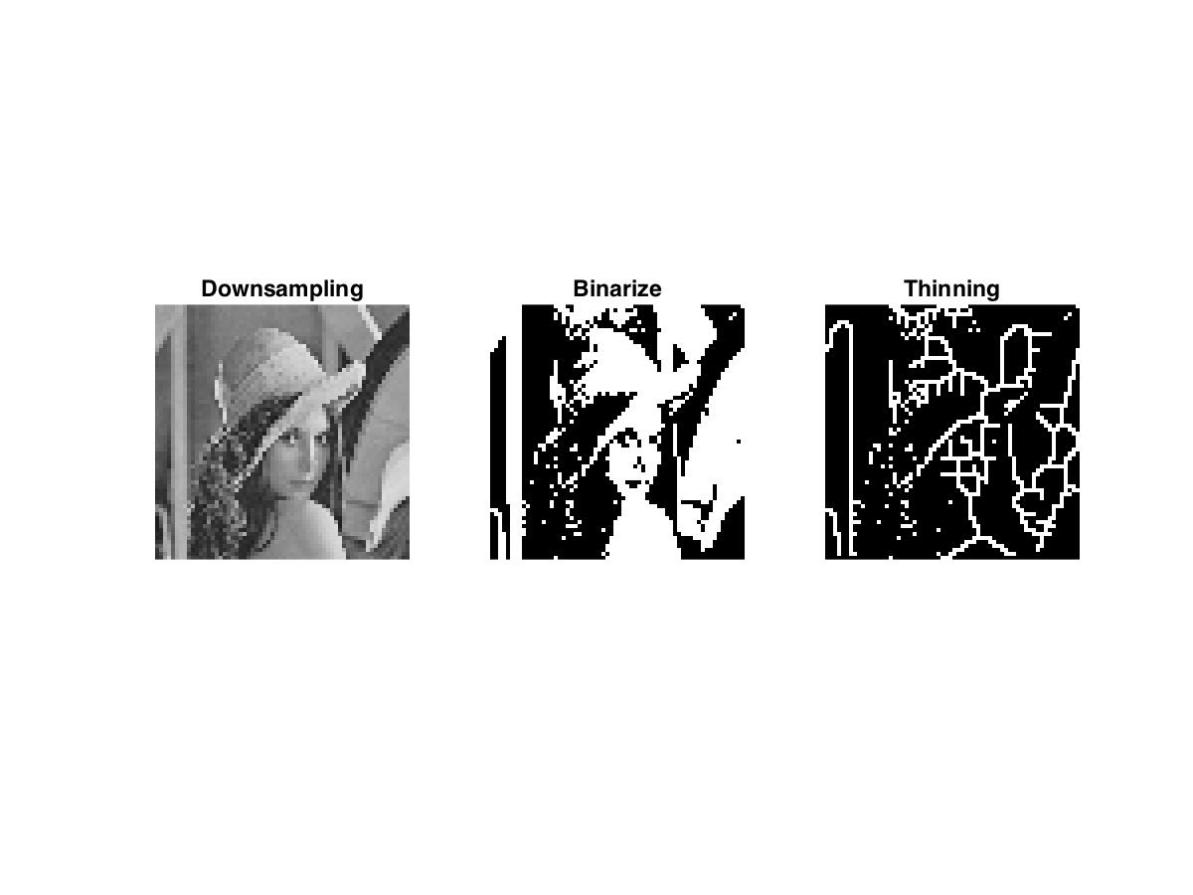

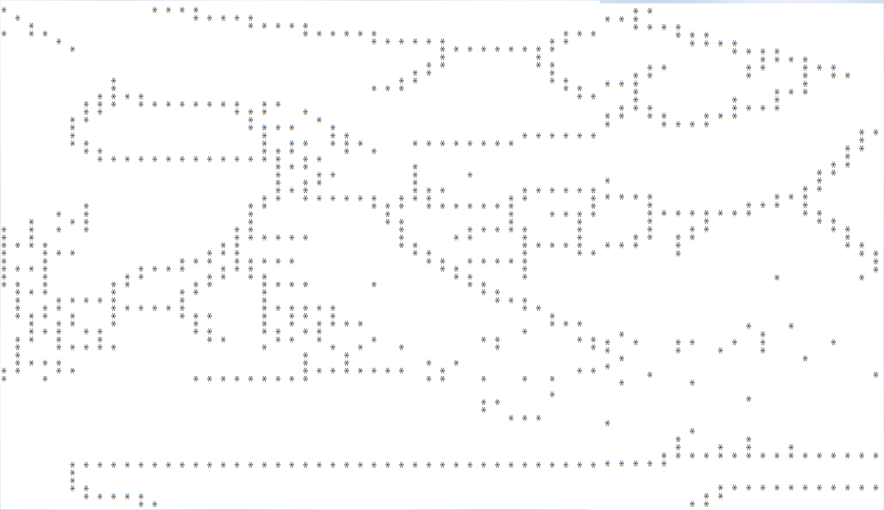

相較於 Connectivity shrink operator，Thinning operator 是一種較對稱的縮小法，縮小的幅度幾乎是上下、左右的對稱。